Alberth Matos
14 April 2026
Lab 5 report
CYOP 300 - BUILDING SECURE WEB APPLICATIONS

Executive Summary
Attached is my submission for our Lab5 activity.
As with previous labs, I made use of 3rd party Python modules to create a text-based UI for application navigation. This is helpful because it prevents the user from entering any unexpected input during functionality selection, eliminating a potential source of bugs. Unlike previous submissions, this lab has made use of a module that fully supports running in both the Windows “Command Prompt” shell, running cmd.exe, as well as the Terminal shell, running Powershell.
Of note is that this lab’s application is split across three python modules, main.py, load_data.py, and lab5ui.py. My original intent was to separate the UI from data processing components, however, after more consideration of the project instructions, I believed that it would introduce unnecessary complexity.
Full unit tests were generated and are included in the project zip file.
Pylint results are included at the end of this report.

Testing

Test Case Table
Test Cases | Description | Expected Output | Actual Output | Pass/Fail
Test Case 1 | Demonstrate handling of missing CSV files:  Rename Housing.csv to a temporary name, execute the program, and then re-name the temporary name back to Housing.csv | Message: Both Housing.csv and PopChange.csv are required. Please ensure they are present in current working directory. | Message: Both Housing.csv and PopChange.csv are required. Please ensure they are present in current working directory. | Pass
Test Case 2 | Demonstrate exiting the application:  Select ‘Exit’ from the top menu | Select the file you want to analyze:  Exit  *************** Thanks for using the Data Analysis App ********** | Select the file you want to analyze:  Exit  *************** Thanks for using the Data Analysis App ********** | Pass
Test Case 3 | Demonstrate exiting a submenu and returning to the main menu:  Select Population Data, then select ‘d. Exit’ | ?  Select the file you want to analyze:  Population Data  You have entered Population Data.  ?  Select the Column you want to analyze:  d. Exit  Exiting Population Data analysis.  ?  Select the file you want to analyze:  Population Data  Housing Data  Exit | ?  Select the file you want to analyze:  Population Data  You have entered Population Data.  ?  Select the Column you want to analyze:  d. Exit  Exiting Population Data analysis.  ?  Select the file you want to analyze:  ❯  Population Data  Housing Data  Exit | Pass
Test Case 4 | Show Population Data – Pop April 1 data and histogram | ?  Select the file you want to analyze:  Population Data  You have entered Population Data.  ?  Select the Column you want to analyze:  a. Pop Apr 1  You selected: Pop Apr 1  The statistics for this column are:  Count = 556  Mean = 49957.3  Standard Deviation = 27250.7  Min = 13519.0  Max = 218478.0  The Histogram of Pop Apr 1 is now displayed. | ?  Select the file you want to analyze:  Population Data  You have entered Population Data.  ?  Select the Column you want to analyze:  a. Pop Apr 1  You selected: Pop Apr 1  The statistics for this column are:  Count = 556  Mean = 49957.3  Standard Deviation = 27250.7  Min = 13519.0  Max = 218478.0  The Histogram of Pop Apr 1 is now displayed. | Pass
Test Case 5 | Show Population Data – Pop April 1 data and histogram without returning to the main menu | ?  Select the file you want to analyze:  Population Data  You have entered Population Data.  ?  Select the Column you want to analyze:  a. Pop Apr 1  You selected: Pop Apr 1  The statistics for this column are:  Count = 556  Mean = 49957.3  Standard Deviation = 27250.7  Min = 13519.0  Max = 218478.0  The Histogram of Pop Apr 1 is now displayed.  The Histogram of this column is now displayed.  You have entered Population Data.  ?  Select the Column you want to analyze:  a. Pop Apr 1  You selected: Pop Apr 1  The statistics for this column are:  Count = 556  Mean = 49957.3  Standard Deviation = 27250.7  Min = 13519.0  Max = 218478.0  The Histogram of Pop Apr 1 is now displayed.  The Histogram of this column is now displayed.  You have entered Population Data.  ?  Select the Column you want to analyze:  ❯  a. Pop Apr 1  b. Pop Jul 1  c. Change Pop  d. Exit | ?  Select the file you want to analyze:  Population Data  You have entered Population Data.  ?  Select the Column you want to analyze:  a. Pop Apr 1  You selected: Pop Apr 1  The statistics for this column are:  Count = 556  Mean = 49957.3  Standard Deviation = 27250.7  Min = 13519.0  Max = 218478.0  The Histogram of Pop Apr 1 is now displayed.  The Histogram of this column is now displayed.  You have entered Population Data.  ?  Select the Column you want to analyze:  a. Pop Apr 1  You selected: Pop Apr 1  The statistics for this column are:  Count = 556  Mean = 49957.3  Standard Deviation = 27250.7  Min = 13519.0  Max = 218478.0  The Histogram of Pop Apr 1 is now displayed.  The Histogram of this column is now displayed.  You have entered Population Data.  ?  Select the Column you want to analyze:  ❯  a. Pop Apr 1  b. Pop Jul 1  c. Change Pop  d. Exit | Pass
Test Case 6 | Show Population Data – Pop July 1 data and histogram | ?  Select the file you want to analyze:  Population Data  You have entered Population Data.  ?  Select the Column you want to analyze:  a. Pop Apr 1  You selected: Pop Apr 1  The statistics for this column are:  Count = 556  Mean = 49957.3  Standard Deviation = 27250.7  Min = 13519.0  Max = 218478.0  The Histogram of Pop Apr 1 is now displayed.  The Histogram of this column is now displayed.  You have entered Population Data.  ?  Select the Column you want to analyze:  a. Pop Apr 1  You selected: Pop Apr 1  The statistics for this column are:  Count = 556  Mean = 49957.3  Standard Deviation = 27250.7  Min = 13519.0  Max = 218478.0  The Histogram of Pop Apr 1 is now displayed.  The Histogram of this column is now displayed.  You have entered Population Data.  ?  Select the Column you want to analyze:  a. Pop Apr 1  b. Pop Jul 1  c. Change Pop  d. Exit | ?  Select the file you want to analyze:  Population Data  You have entered Population Data.  ?  Select the Column you want to analyze:  a. Pop Apr 1  You selected: Pop Apr 1  The statistics for this column are:  Count = 556  Mean = 49957.3  Standard Deviation = 27250.7  Min = 13519.0  Max = 218478.0  The Histogram of Pop Apr 1 is now displayed.  The Histogram of this column is now displayed.  You have entered Population Data.  ?  Select the Column you want to analyze:  a. Pop Apr 1  You selected: Pop Apr 1  The statistics for this column are:  Count = 556  Mean = 49957.3  Standard Deviation = 27250.7  Min = 13519.0  Max = 218478.0  The Histogram of Pop Apr 1 is now displayed.  The Histogram of this column is now displayed.  You have entered Population Data.  ?  Select the Column you want to analyze:  ❯  a. Pop Apr 1  b. Pop Jul 1  c. Change Pop  d. Exit | Pass
Test Case 7 | Show Population Data – Change Pop data and histogram | ?  Select the file you want to analyze:  Population Data  You have entered Population Data.  ?  Select the Column you want to analyze:  c. Change Pop  You selected: Change Pop  The statistics for this column are:  Count = 556  Mean = 154.8  Standard Deviation = 3050.6  Min = -13775.0  Max = 22363.0  The Histogram of Change Pop is now displayed. | ?  Select the file you want to analyze:  Population Data  You have entered Population Data.  ?  Select the Column you want to analyze:  c. Change Pop  You selected: Change Pop  The statistics for this column are:  Count = 556  Mean = 154.8  Standard Deviation = 3050.6  Min = -13775.0  Max = 22363.0  The Histogram of Change Pop is now displayed. | Pass
Test Case 8 | Show Housing Data - Age | ?  Select the file you want to analyze:  Housing Data  You have entered Housing Data.  ?  Select the Column you want to analyze:  a. AGE  You selected: AGE  The statistics for this column are:  Count = 10042  Mean = 47.2  Standard Deviation = 23.1  Min = -9.0  Max = 93.0  The Histogram of AGE is now displayed. | ?  Select the file you want to analyze:  Housing Data  You have entered Housing Data.  ?  Select the Column you want to analyze:  a. AGE  You selected: AGE  The statistics for this column are:  Count = 10042  Mean = 47.2  Standard Deviation = 23.1  Min = -9.0  Max = 93.0  The Histogram of AGE is now displayed. | Pass
Test Case 9 | Show Housing Data - Bedrooms | ?  Select the file you want to analyze:  Housing Data  You have entered Housing Data.  ?  Select the Column you want to analyze:  b. BEDRMS  You selected: BEDRMS  The statistics for this column are:  Count = 10042  Mean = 2.7  Standard Deviation = 1.1  Min = 0.0  Max = 7.0  The Histogram of BEDRMS is now displayed. | ?  Select the file you want to analyze:  Housing Data  You have entered Housing Data.  ?  Select the Column you want to analyze:  b. BEDRMS  You selected: BEDRMS  The statistics for this column are:  Count = 10042  Mean = 2.7  Standard Deviation = 1.1  Min = 0.0  Max = 7.0  The Histogram of BEDRMS is now displayed. | Pass
Test Case 10 | Show Housing Data - Built | ?  Select the file you want to analyze:  Housing Data  You have entered Housing Data.  ?  Select the Column you want to analyze:  c. BUILT  You selected: BUILT  The statistics for this column are:  Count = 10042  Mean = 1967.0  Standard Deviation = 26.3  Min = 1919.0  Max = 2012.0  The Histogram of BUILT is now displayed. | ?  Select the file you want to analyze:  Housing Data  You have entered Housing Data.  ?  Select the Column you want to analyze:  c. BUILT  You selected: BUILT  The statistics for this column are:  Count = 10042  Mean = 1967.0  Standard Deviation = 26.3  Min = 1919.0  Max = 2012.0  The Histogram of BUILT is now displayed. | Pass
Test Case 11 | Show Housing Data - Rooms | ?  Select the file you want to analyze:  Housing Data  You have entered Housing Data.  ?  Select the Column you want to analyze:  d. ROOMS  You selected: ROOMS  The statistics for this column are:  Count = 10042  Mean = 5.7  Standard Deviation = 1.9  Min = 1.0  Max = 14.0  The Histogram of ROOMS is now displayed.  You have entered Housing Data. | ?  Select the file you want to analyze:  Housing Data  You have entered Housing Data.  ?  Select the Column you want to analyze:  d. ROOMS  You selected: ROOMS  The statistics for this column are:  Count = 10042  Mean = 5.7  Standard Deviation = 1.9  Min = 1.0  Max = 14.0  The Histogram of ROOMS is now displayed.  You have entered Housing Data. | Pass
Test Case 12 | Show Housing Data - Utility | ?  Select the file you want to analyze:  Housing Data  You have entered Housing Data.  ?  Select the Column you want to analyze:  e. UTILITY  You selected: UTILITY  The statistics for this column are:  Count = 10042  Mean = 189.6  Standard Deviation = 128.9  Min = 0.0  Max = 1107.6  The Histogram of UTILITY is now displayed. | ?  Select the file you want to analyze:  Housing Data  You have entered Housing Data.  ?  Select the Column you want to analyze:  e. UTILITY  You selected: UTILITY  The statistics for this column are:  Count = 10042  Mean = 189.6  Standard Deviation = 128.9  Min = 0.0  Max = 1107.6  The Histogram of UTILITY is now displayed. | Pass
Test Case 13 | Runs on Windows without WSL | Run program, select any menu options required to generate a histogram. | (cyop300) PS Z:\> cmd.exe  Microsoft Windows [Version 10.0.26100.8037]  (c) Microsoft Corporation. All rights reserved.  Z:\>exit  (cyop300) PS Z:\> python main.py  ***************** Welcome to the Python Data Analysis App **********  ?  Select the file you want to analyze:  Population Data  You have entered Population Data.  ?  Select the Column you want to analyze:  a. Pop Apr 1  You selected: Pop Apr 1  The statistics for this column are:  Count = 556  Mean = 49957.3  Standard Deviation = 27250.7  Min = 13519.0  Max = 218478.0  The Histogram of Pop Apr 1 is now displayed. | Pass

Test Case Screenshots

Test Case 1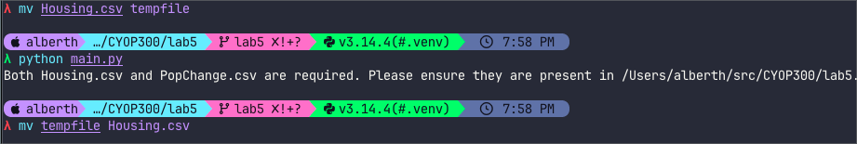

Test Case 2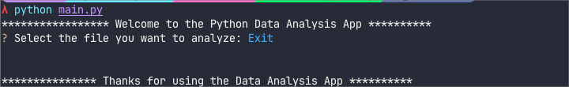

Test Case 3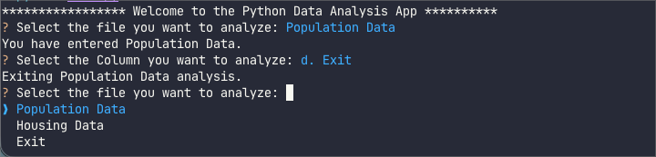

Test Case 4

Test Case 5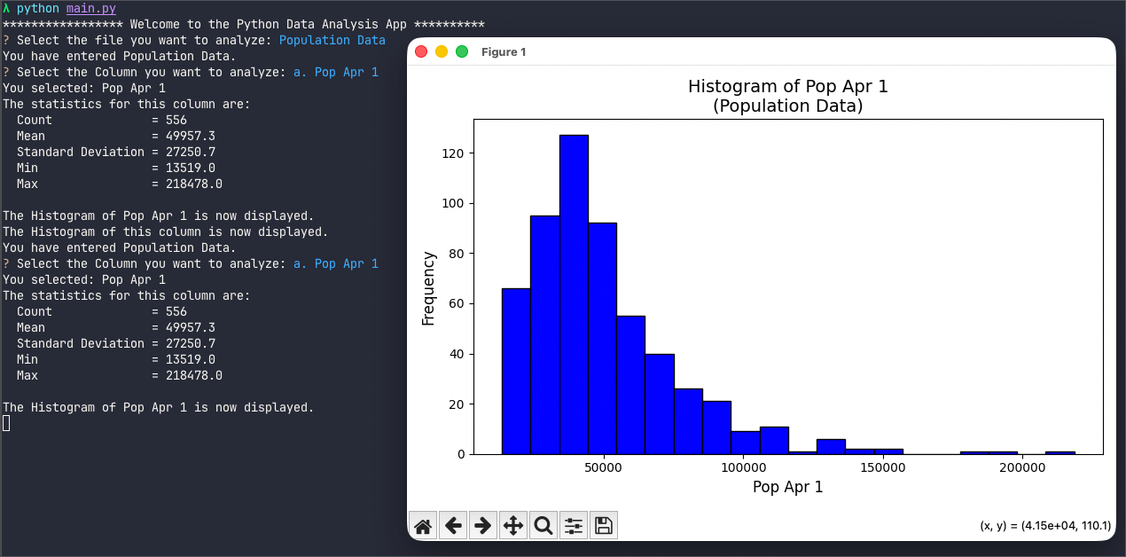

Test Case 6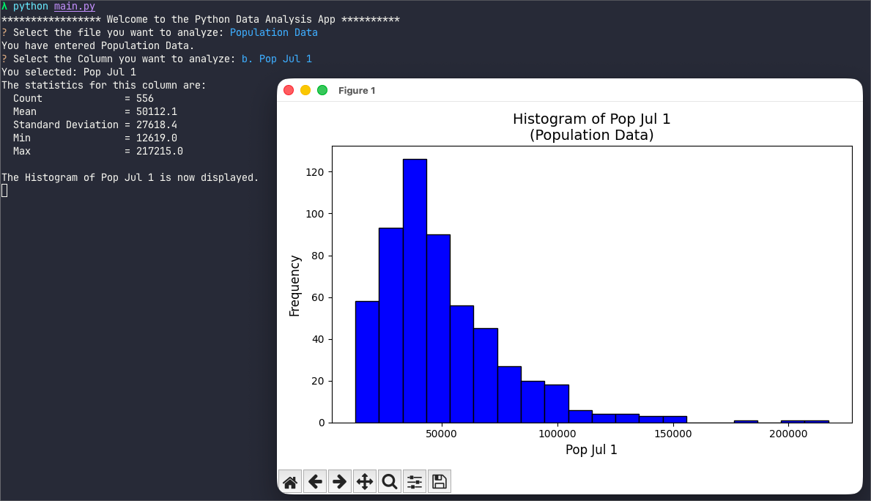

Test Case 7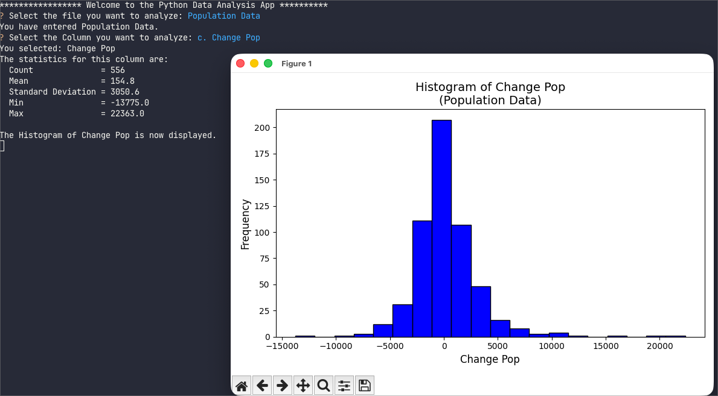

Test Case 8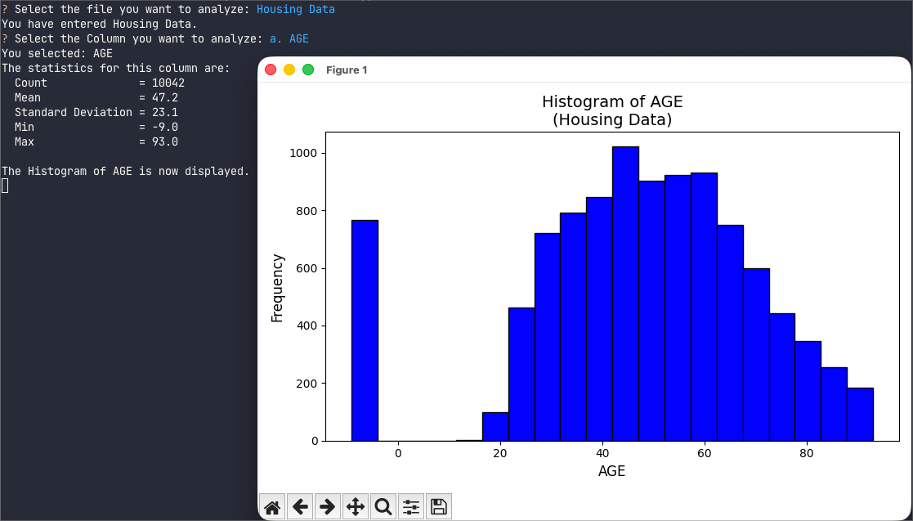

Test Case 9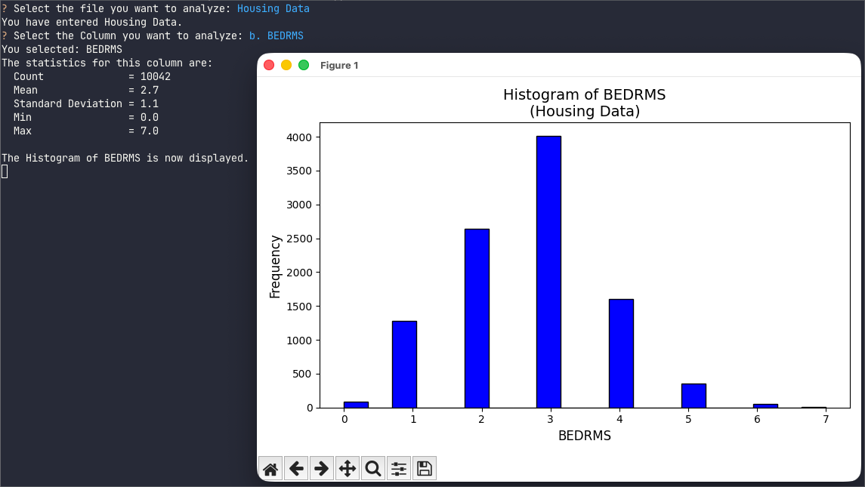

Test Case 10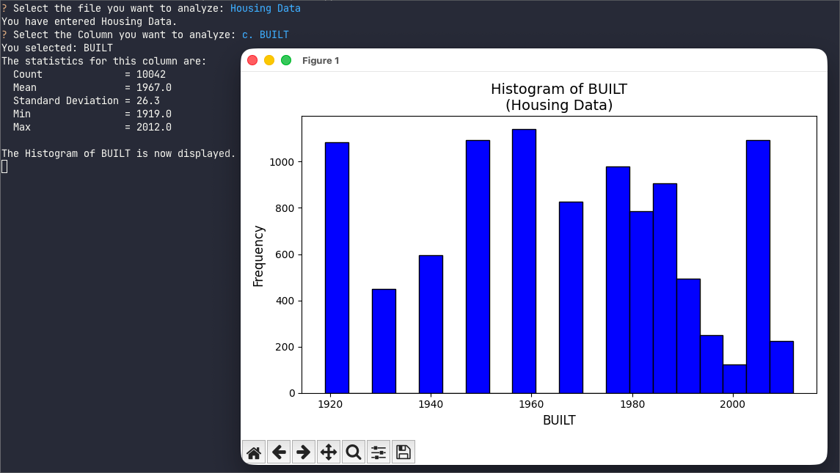

Test Case 11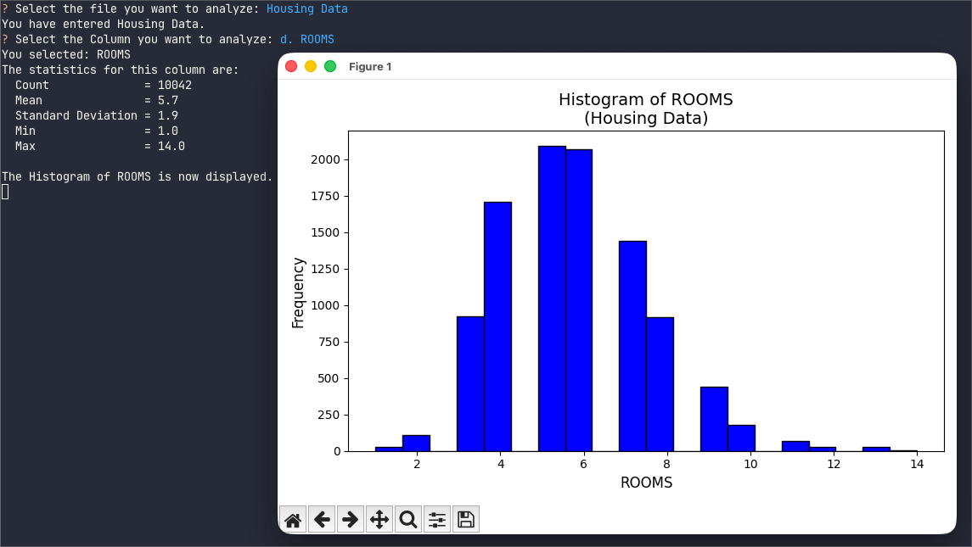

Test Case 12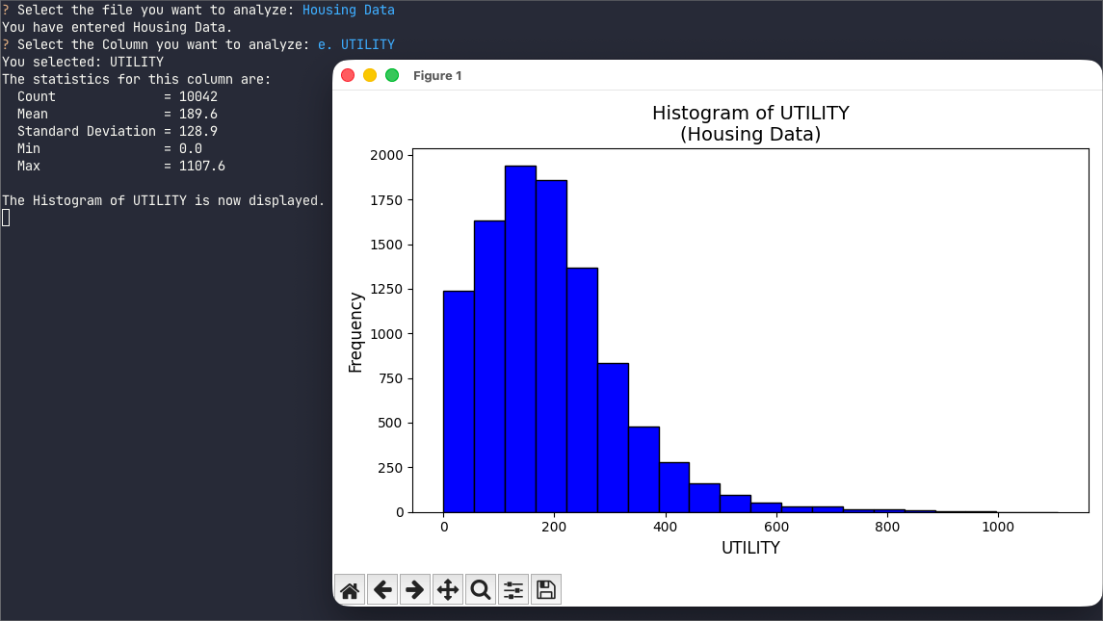

Test Case 12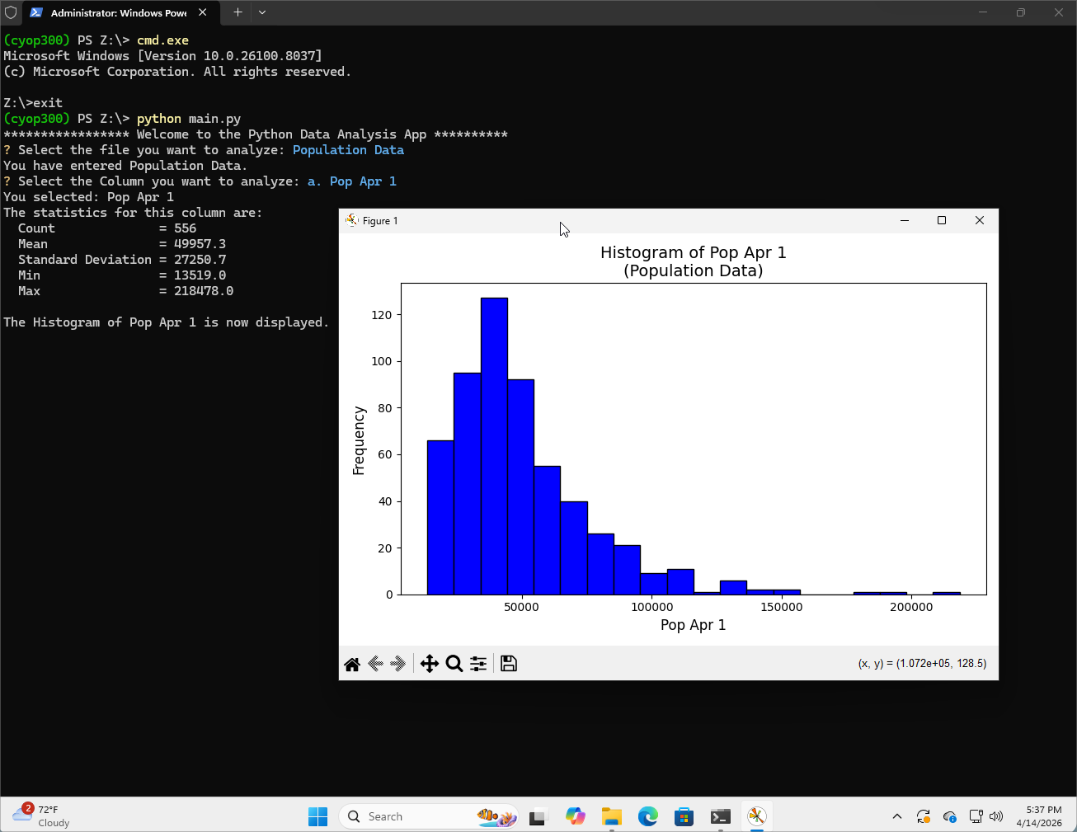

Pylint Results
λ pylint *.py
------------------------------------
Your code has been rated at 10.00/10

